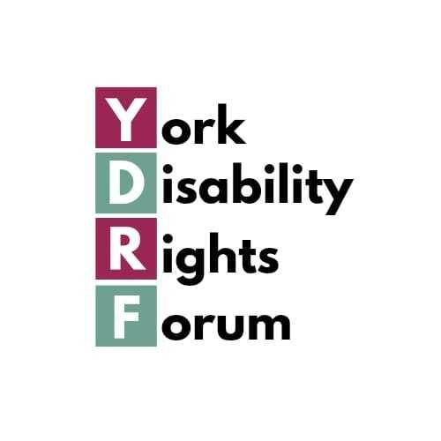
Nominations for Steering Group Members and Officers
York Disability Rights Forum AGM
Thursday 25th June 2026

Please send your nominations by email, mail or voicemail (details below) by the end of Friday 18th June if possible (nominations can also be accepted at the AGM itself).

This form is also available to complete online.

- There are 12 steering group places including co-optees
- There are 8 places available for nominations this time (one third of places becomes available each year including any vacancies)

Voting
- Is open to members
- Is by a show of hands
- All Steering Group nominees must be members or allies

Please let us know in advance if you would like to use an alternative method to vote.

Nominating
Please check with the person you’re nominating that they agree to being nominated before putting them forward.

If they are not sure if they are a member, please ask them to contact us (details below). We welcome Steering Group members with a wide range of impairments and health conditions and from diverse backgrounds.

Nomination Form
Complete this form online

Name of person you’re nominating (please print): __________________________

If you wish to nominate more than one person, please add their names below:

Your name (please print): _____________________________________________________

Nominations of Officers
(Please note: elections of Officers are by members present at AGM). The Chair/Co Chair must be a full member; other Officers may be full members or allies. If you would like to nominate someone for an Officer position, please complete the form below.

Chair/Co Chair: ______________________________________________________________

Secretary: ___________________________________________________________________

Treasurer: ____________________________________________________________________

Your Name (please print): ___________________________________________________

Please return by the end of Friday 18th June if possible.

