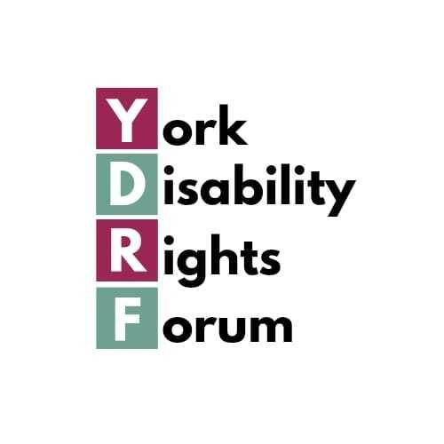
York Disability Rights Forum Annual General Meeting 2026
2.00-4.30pm, Thursday 25th June 2026
In person: Penn Room, Friargate Meeting House, York
Online: by Zoom

Whether you are a full member, ally, supporter or simply curious about getting involved, you are most welcome.

Your experience, ideas and involvement are what keeps us going.

Here you’ll find information about what’s planned for the meeting, details about our guest speaker, how to let us know you’re coming (if possible), and about access to the venue.

2.15 to 3.00pm
(AGM agenda - the business part)
- Welcome and Apologies
- Minutes from the 2025 AGM
- Chair’s Annual Report and verbal reports from our subgroups
- Treasurer’s Report
- Election of Steering Group members – there are eight places available for which 3 existing members are standing for reselection and one co-opted member standing for election, so 4 places currently without any nominees
- Nomination and Election of Officers:
Chair/Co Chairs; Vice Chair; Treasurer; Secretary
- Amendment to our Constitution
- Appointment of Auditors (if required)
- General Data Protection Regulations (GDPR)
- Any Other Business
- Date and Venue of next AGM

3.00 to 3.45pm
Guest speaker and discussion
Anna Bramwell-Dicks, University of York, will tell us about her work on the role of new technology, media and music in improving access, health and wellbeing.

About Anna
Anna has a long-standing interest in the role of new technologies, media and music in improving access, health and wellbeing. Anna started out by doing an undergraduate degree in Electronic Engineering with Music Technology Systems and became so fascinated by User-Centred Design and Psychology that she ended up doing a PhD focussing on the effect of music on transcription typing performance and experience. Anna has since done lots of work on accessibility and disability representation focused projects, including ‘Playable Bodies: Disability Representation in Immersive Media and Video Games’ and ‘SoundCeption: Multimodal Sensory Substitution’ (she’ll explain what this means!). Anna is the Subject Head of Creative Technologies & Senior Lecturer in Interactive Media at the School of Arts and Creative Technologies, University of York and is Chair of the International Federation of Information Processing Working Group 13.3 on Human-Computer Interaction, Disability and Aging.

3.45 to 4.30pm
A relaxed opportunity to chat, get to know each other and connect with other members, allies and supporters of YDRF.

The AGM is a place where people can contribute ideas, experiences and perspectives that strengthen YDRF and disabled-led change in York.

Whether in-person or online, we’d love for you to join us.

Please book online or let us know you’re coming by the end of Friday 18 June if possible as it helps us to plan the meeting. You’re also welcome to turn up on the day.

If you’re planning to attend online, please book a ticket so we can send you the meeting link.

email: hello@ydrf.org.uk
voicemail: 01904 326781
post: YDRF c/o Centre for Applied Human Rights, 6 Innovation Close, York, YO10 5ZF

Friargate Meeting House has step free access and wheelchair accessible toilets; BSL interpreters will be available for in-person and online attendees. Please get in touch if you have any other access needs and we will do our best to meet them.

We recognise the time and/or day of the AGM will not be suitable for everyone so please let us know if this affects you. We’re keen to encourage as many as possible to attend. We also hope to attract new members for our steering group and sub-groups! Do get in touch if you’re interested!

