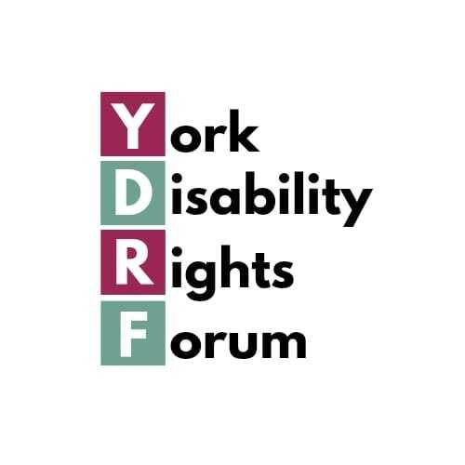

York Disability Rights Forum AGM Minutes, 3rd July 2025 held at New Earswick Folk Hall and online

Present: (members and allies)(in person and online) Helen Jones, Eleanor Tew, Hilary Conroy, Hazel Kerrison, Marilyn Crawshaw, Francess Daly, Tasha Taylor, Ashley Fisher, Danila Taylor, Ray Taylor, Ruth Phillips, Joanne Chapman, Lu McConville, Lali Hewitson, Saffron
Apologies: (members and allies) Abi Bubb, Jane Burton, Anne Norton, Srish Agen, Dionne Grover-Jacques, Diane Roworth, Anne Norton, Marije Davidson

NOTE – we slightly altered the order of the Agenda to enable our Guest Speaker to be able to leave before the end of our formal business. The Minutes themselves follow the Agenda order.

- Welcome – Helen welcomed all to our third AGM and noted the apologies.

- Minutes of 2024 AGM were accepted without amendment – proposed by Hilary Conroy and seconded by Tasha Taylor.

- Annual Report – Helen introduced the annual report. Printed copies were made available and it will also be made available electronically. Each subgroup reported verbally on their work over the year and their reports also appear in the Annual Report itself: access; benefit cuts; LGBTQ+; neurodivergence; Stop Disability Hate. A very recent written statement about the benefit cuts, compiled by Anne Norton, was also read out. A written report was received and read out from Srish Agen, the YDRF rep on York Climate Commission ‘Connecting with Green Spaces’ subgroup. A verbal report was given by Danila Taylor on her involvement with the IER-UK group of people with lived experience, chaired by Shamim Eimann, that feeds into the Council’s anti-racist strategy.

- Treasurer’s Report – this was included within the Annual Report The balance at 30th June 2025 was £2,009.70. Most of the expenditure was on room bookings, BSL interpreters and postage stamps. The account is held at Open Collective and hence available for anyone to view at any time – https://opencollective.com/york-disability-rights-forum. There were no questions on the financial report.

- Nominations for Steering Group – three current members, Abi Bubb, Helen Jones and Eleanor Tew were standing for re-selection today, for 3 years.
All 3 were nominated by Ashley Fisher and seconded by Hilary Conroy
All 3 were elected unanimously.
There were no other nominations, although we do have two vacancies. Helen encouraged anyone interested in standing to discuss it with any of the steering group and they would be made most welcome.

- Election of Officers
Chair – Ashley Fisher - proposed by Helen Jones; seconded by Hilary Conroy. Elected unanimously. The meeting warmly thanked Helen for all her work as YDRF’s first Chairperson.
Vice Chair – Eleanor Tew - proposed by Helen Jones; seconded by Tasha Taylor. Elected unanimously.
Treasurer – Tasha Taylor - proposed by Helen Jones; seconded by Hilary Conroy. Elected unanimously.
Secretary – Marilyn Crawshaw - proposed by Hilary Conroy; seconded by Helen Jones. Elected unanimously.

- Appointment of Auditors – we are not currently required to have our accounts audited.

- GDPR – Marilyn reported that YDRF is GDPR compliant and that there have been no data breaches this year.

- Any other business – Helen thanked the volunteers that we have used from York Human Rights City Network.

- Date and venue of next AGM – To be confirmed

There was a presentation by our Guest Speaker, Laura Swiszczowski, the new Head of EDI at the council. Laura has been in post since 5th March and has been hard at work since. She was responsible for rewriting the Council’s EDI Three Year Strategy, taking account of consultation responses to the draft. It is due to go the Council Executive for approval on 15th July. Laura has also been continuing the work with the Centre for Applied Human Rights, University of York, on finalising the new Human Rights and Equity Impact Assessment tool that is due to be rolled out shortly. Thirty four council staff from a range of sectors and levels have signed up to receive the training on it next week (with CAHR) and will act as ‘human rights champions’.
Work is also underway to improve the diversity of the council’s workforce across all protected characteristics. Laura also expressed her commitment to going beyond the statutory list of people with protected characteristics in driving all EDI work forward. Laura is also instigating EDI training with an ati-racist and intersectional focus and is running a workshop for YDRF and York Access Forum to co-design the objectives of disability equality/social model training that she is commissioning. Laura stressed the importance of findings ways to make the training sustainable in its application.
In response to a question from the audience, Laura talked a little about the threats and opportunities that she envisaged coming from AI. In response to another question, she also expressed her commitment to the importance of retaining non-digital forms of communication for those that need it.

